PRESS RELEASE
COMMUNICATIONS AND MEDIA TEAM OF THE 43RD ASEAN SUMMIT 2023
No.90/SP/TKM-ASEAN2023/ENG/9/2023

Welcoming the New Friends of ASEAN
Jakarta, 6 September 2023 – Indonesia's chairmanship of ASEAN in 2023 provides many new perspectives for the progress and future of the region. A number of cooperation agreements within and between regions, especially in the Indo-Pacific region, were signed during the the Summits, namely the 42nd ASEAN Summit in Labuan Bajo, East Nusa Tenggara on 9-11 May 2023 and the 43rd ASEAN Summit at the Jakarta Convention Center, Jakarta on 5-7 September 2023.
During the ASEAN Foreign Ministers' Meeting (AMM) at the ASEAN Secretariat, Jakarta, Monday, 4 September 2023, ASEAN, the world’s fifth largest economy, has once again established new collaborations. In the meeting, ASEAN agreed to collaborate with the Association of Indian Ocean Rim Association (IORA). The IORA organization was established on 7 March 1997 and consists of 23 countries including Australia, France, United Arab Emirates, Malaysia, Thailand, Singapore and Indonesia.
Like ASEAN, IORA also has a number of dialogue partners such as the United States, The United KIngdom, Germany, Italy, Japan, South Korea and China. Currently, the Indonesian Ambassador to South Africa Salman Al Farisi, serves as Secretary-General of IORA and Bangladesh’s Foreign Minister Abdul Momen serves as the Chair of IORA. Secretary-General of IORA Salman Al Farisi on behalf of IORA and Secretary-General of ASEAN Kao Kim Hourn on behalf of ASEAN signed a Memorandum of Understanding (MoU) between IORA and ASEAN.
There cooperation priority areas include the maritime sector, inter-regional connectivity, sustainable development, blue economy, green economy, digital economy, and disaster mitigation management. A similar cooperation was also signed by the Secretary-General of ASEAN Kim Hourn with the Deputy Secretary General of the Pacific Islands Forum (PIF) Esala Nayasi, a senior diplomat at the Fiji Foreign Affairs Ministry
PIF is a regional organization that consists of 18 countries in the north and south of the Pacific Ocean which was founded in 1971 at the initiative of New Zealand. The purpose of establishing PIF is to strengthen cooperation and integration, by pooling local resources and unifying policies to achieve economic growth, sustainable development, good governance, and security. Indonesia has also been one of 21 Post-Forum Dialogue Partners since 2001. Currently, the Cook Islands holds the PIF chairmanship.
Indonesian Foreign Affairs Minister Retno Marsudi and Cook Islands Prime Minister Mark Brown witnessed the signing of MoU between ASEAN and IORA and PIF.
Foreign Minister Retno stated that countries in the Indian and Pacific Oceans constitute an inseparable part of the Indo-Pacific region. ASEAN and countries in the Indian and Pacific Oceans must work together to maintain regional peace, stability and prosperity.
"Anything that happens in this area will affect all of us. Please note, if you want to go fast, go alone. But if you want to go far, go together. I'm sure we all want to go far," said Foreign Minister Retno.
Not only IORA and PIF
IORA and PIF were not the only ones to begin cooperation with ASEAN. On the same day, three countries forged cooperation in the form of Treaty of Amity and Cooperation (TAC). The three countries are Serbia, represented by First Deputy Prime Minister and Foreign Minister Ivica Dacic, Panama represented by Foreign Minister Vladimir Franco, and Kuwait represented by Kuwaiti Foreign Affairs Deputy Minister Sheikh Jarrah Jaber Al-Ahmad Aljabeer Al-Sabah.
The three became the 52nd, 53rd and 54th countries respectively to accede the treaty. The TAC was established at the 1976 ASEAN Summit. Previously, Saudi Arabia had also signed the TAC in July 2023. The TAC is a cooperation pact that promotes the adoption of the principle of non-aggression by ASEAN countries and partner countries. The TAC aims to promote peace, friendship, and cooperation among Southeast Asia Nations.
This is expected to contribute to the region’s strength, solidarity, and closer relations. By acceding to the treaty, countries will need to ensure that their acts abide by the fundamental principles of mutual respect for independence, sovereignty, equality, territorial integrity and national identity of all nations.
Countries that are party to the treaty should also respect the right of every country to defend its national sovereignty from external interference, subversion or coercion, as well as to settle differences or disputes by peaceful means. "Over the years, the TAC has played an important role as a collective norm and principle to encourage good relations, dialogue habits, and peaceful co-existence in the region," said Foreign Minister Retno.
All permanent members of the United Nations Security Council have signed the TAC, namely China (2003), Russia (2004), France (2007), the US (2009), and the United Kingdom (2012). Meanwhile, of the G20 members, only two countries have not acceded, namely Italy and Mexico. (Anton Setiawan/TR/Elvira Inda Sari)
***

For more information, please contact:
Director General of Public Information and Communications of the Ministry of Communications and Informatics – Usman Kansong (0816785320).
Get more information at http://asean2023.id, https://infopublik.id/kategori/asean-2023, and https://indonesia.go.id/kategori/ragam-asean-2023

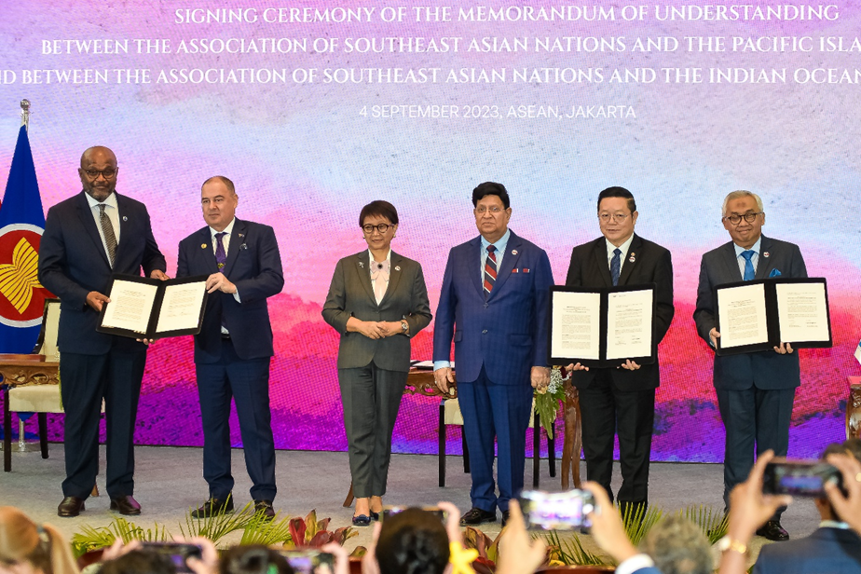
(from left) Deputy Secretary General of the Pacific Islands Forum (PIF) Esala Nayasi, Cook Islands Prime Minister Mark Brown, Indonesian Foreign Affairs Minister Retno Marsudi, Bangladesh Foreign Minister Abdul Momen, Secretary-General of ASEAN Kao Kim Hourn and Secretary-General of IORA Salman Al Farisi witnesses the signing of MoU between ASEAN Secretariat and IORA and PIF at the ASEAN Secretariat Building Jakarta, Monday, 4 September 2023. ANTARA PHOTOS/Media Center of ASEAN Summit 2023/Rommy Pujianto/foc.

